Journal 5

package mypack;

public class demopackage

{

int r;

public void getinfo(int r)

{

this.r=r;

}

public void area()

{

System.out.println("area of circle="+(3.14\*r\*r));

}

public void circum()

{

System.out.println("circumference of circle="+(2\*3.14\*r));

}

}

Import

import mypack.\*;

public class circle

{

public static void main(String args[])

{

demopackage d=new demopackage();

d.getinfo(2);

d.area();

d.circum();

}

}

Output

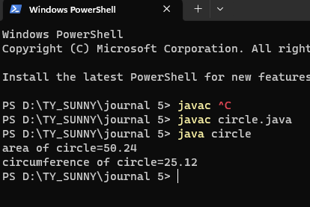

2

package p1;

public class demop

{

public void display()

{

System.out.println("welcome to package");

}

}

Import

import p1.\*;

public class ex1

{

public static void main(String args[])

{

demop d=new demop();

d.display();

}

}

Output

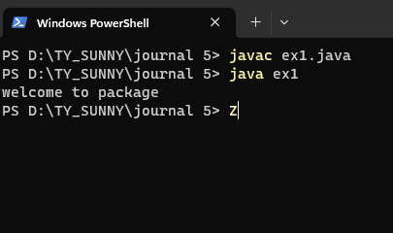

3

package extvariable;

public class edemo

{

public int no1,no2;

}

Import

import extvariable.\*;

public class vdemo

{

public static void main(String args[])

{

edemo e=new edemo();

e.no1=10;

e.no2=20;

int sum=e.no1+e.no2;

System.out.println("addition="+sum);

}

}

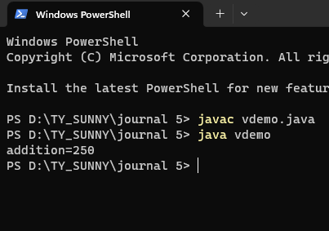

4

package userdefined;

public class packagedemo

{

public int no1=10,no2=20;

}

Import

import userdefined.\*;

public class calculation

{

public static void main(String args[])

{

packagedemo p=new packagedemo();

int sum=p.no1+p.no2;

System.out.println("addition="+sum);

int sub=p.no1-p.no2;

System.out.println("substraction="+sub);

}

}

Output

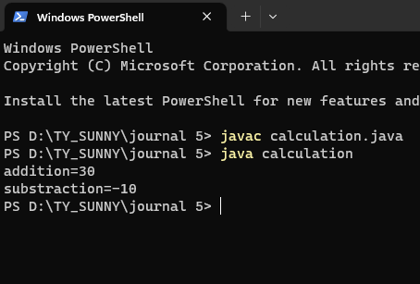

5

package calculator;

public class cal

{

int a,b;

public void getinfo(int a,int b)

{

this.a=a;

this.b=b;

}

public void sum()

{

System.out.println("addition="+(a+b));

}

public void sub()

{

System.out.println("substraction="+(a-b));

}

public void mul()

{

System.out.println("multiplication="+(a\*b));

}

public void div()

{

System.out.println("division="+(a/b));

}

}

Import

import calculator.\*;

public class democalculator

{

public static void main(String args[])

{

cal c=new cal();

c.getinfo(100,20);

c.sum();

c.sub();

c.mul();

c.div();

}

}

Output

